The Eden Kid’s Garden
A project of The Eden Kid’s Foundation Trust ‘Developing young lives’
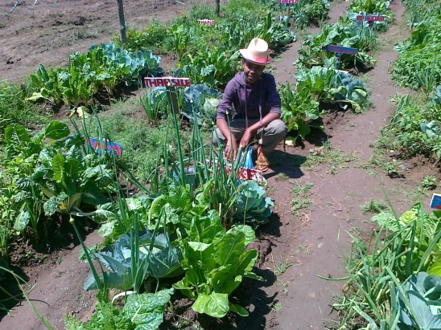

Background
Eden Kid’s Trust was established by Pastor Joel Ruttenberg in Jan 2013 in response to a need in the Informal settlement called Jika Joe in Pietermaritzburg inner- city. The Eden Kid’s Garden was initiated by Godly inspiration. After doing a teaching on the Sower and the Four soils, Pastor Joel suggested to the group of disadvantaged children from Jika Joe that they start a veggie garden. The Kids were so excited and the garden was established with the children’s full involvement.
“FFFO” Strategy
The 3 F’s and an O . We have found that these elements greatly help and are integral to make a happy and sustainable children’s garden.
Faith- integration of lessons and teachable opportunities by using visual aids that are displayed in the garden
Food- the kids harvest spinach and cabbage for home consumption. Healthy Food security is therefore enhanced
Fun- When work is mixed with fun it becomes much easier. Playground equipment is erected in the garden, competitions are run regularly for neatest garden, best mulched garden, biggest cabbage etc.
Ownership- a door sized garden is manageable in a small child’s eyes and once ownership is attained, pride and zeal are promoted, resulting in a successful project and a valuable life skill!
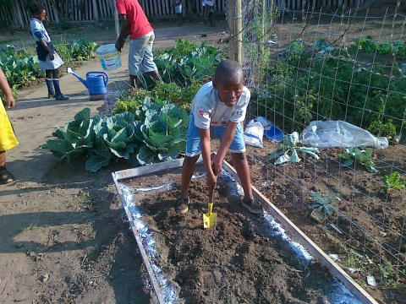
Design
French door garden system: The main element of this age old approach was that the size of a door is manageable for children and also gives them ownership of their personal piece of ground.
Frame: To ensure uniformity nail four pieces of wood together in out-line of a door. A frame of sticks tied together can also be used. Lay this on the ground and using agricultural lime as a making agent, pour a thin stripe around inside of frame to mark out the garden bed. Use the frame to mark all the beds in a straight line.

Playground: Place playground equipment inside the fence perimeter of the garden at the back of so kids have to pass through the gardens to reach the play area.
Access control: Fence the garden and only allow access under supervision. Children first water (by watering can, not hosepipe) and weed then are allowed to play on jungle gym and swings.

Involvement
Garden Project leader/Champion: This person ideally must be one of the teachers who know the kids. He/she will organise and supervise work in the garden, planting days, clean-ups, order compost, mulch, seeds or seedlings. Children cannot be left to their own devices, all work and play in the garden must be under supervision. Without a point person like this, the best garden will become a weed patch. The Champion needs to be in love with the concept and be given a lot of support and encouragement. Choose this person wisely.
Church involvement: It is vital to have local church involvement and support especially for big events like when launching the garden or re-planting! Pre-school and primary school kids don’t have the strength to turn the soil and mix in the compost and even need help in planting seedlings.
Parental involvement Parents are important as encouragers and with practical help for maintenance of playground equipment. Adults will often go home and replicate what they have seen their children do.
Kids involvement: Children must be given ownership of their small piece of ground. This creates “buy-in” and can be promoted by the use of individual finger painted name plaques! Watering by hand, weeding, mulching, composting and planting must be done by children under supervision.
Corporate involvement: It is important to try finding a corporate investor that would be able to help supply seedlings and compost. Prepare a garden prospectus and then approach your local nursery or business.
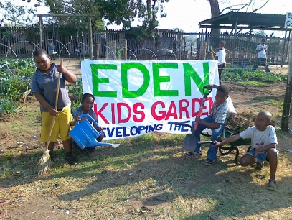
Social Media: Give the garden a name and identity and the best way is a Facebook page. For security of children avoid close-up pictures and get parent’s permission before posting photos on social media. Post pictures of the work being done or of any events in the garden. This helps with spreading the word and networking. A garden notice board and Garden newsletter can also be considered.

Ministries
- The Garden of Eden Genesis Chap 2 (establishment of the garden).
Prepare a ministry on creation with particular emphasis on the Garden of Eden. At the end of the story ask the kids if they would like to also make a beautiful garden. Have your frame and lime ready to mark out beds with the kids help.

- The Sower & the Four Soils. Luke Chap. 8 (the maintenance of the garden)
Teach the parable of the sower- bring to the lesson some weeds with thorns, rocks, hard clods of earth and some rich compost. Let the kids touch the different items and explain that God want us to have hearts like the compost and our kids garden should be the same! This teaching comes before a re- planting.
- The Acts 2 Church Acts 2 : 42- 47 (the establishment of the outreach garden)
Teach about how the early church shared everything in Acts 2 and suggest that there be an area in the garden dedicated to the least privileged in the community. Make a wooden sign and pencil in the words, “Outreach Garden, James 1:27” Help the children to finger paint the sign and then plant it in the spot where the “garden within a garden” will be.
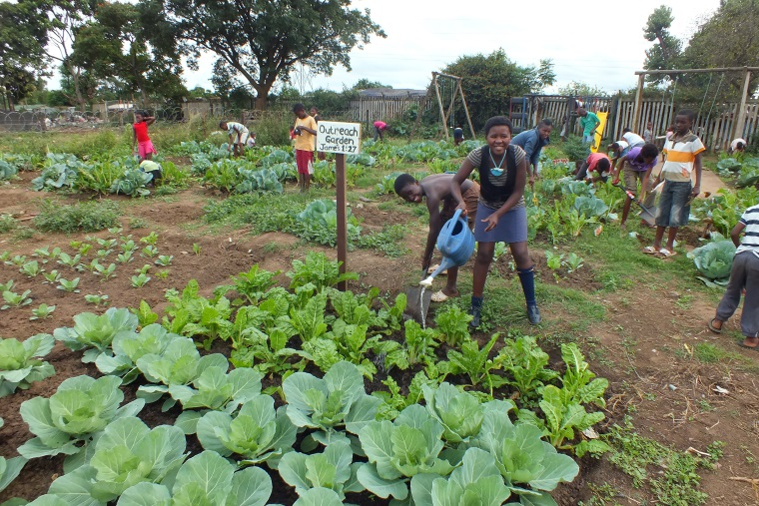

- The 10 commandments for Children Exodus 20 (stop & go signs)
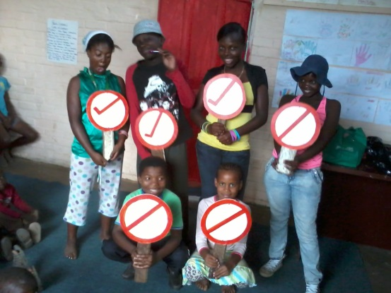
Relate the story of Moses bringing down the 10 commandments to the Israelites using a children’s bible with pictures. Then explain that there are also commandments for children. Ask them to think of some. Guide them to choose age appropriate commandments like Listen, Obey, Read, Pray and then some “do not’s” like No swearing, no fighting, no pushing, etc. Before the lesson get a father to cut some circular pieces of Masonite, and paint them white and when dry, paint a red circle around the perimeter the same as a stop sign. A red line through the middle will mean “no” and a red tick will mean “yes” Bring paint to the lesson and after the commandments have been decided, let the kid’s finger paint the words onto the signs. Then attach the signs to fence poles or jungle gym in the garden for future reference and teachable moments.

- Daniel, Veggies are good for you Daniel Chap 1 (replanting)
Tell the story of how Daniel refused the kings oily food and asked for vegetables. Get some carrots and cut up carrot sticks for the kids to chew during the lesson. At the end of the lesson suggest that it’s time for replanting. Make sure you have seedlings ready for planting. Cabbage grows well and spinach is good because they can be harvested a few leaves every week. Reiterate how healthy veggies are while the replanting is being done and tell the kids how happy Daniel would have been to see their work!

- The Name of the Lord Exodus Chap 3 (Making name plaques for each child)
Use your children’s bible to tell the story of Moses’s encounter with God through the burning bush and make special emphasis of when God names himself. Then ask the children if they would also like to have their names on their gardens, Prepare name boards from wood with little poles. Paint them white before the lesson and assist the kids to finger paint their names on the boards and to decorate them. Then go into the garden and plant them. This is a perfect opportunity to involve a church or parents in the project.

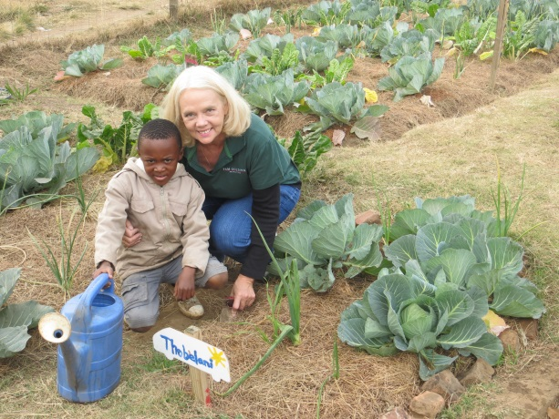
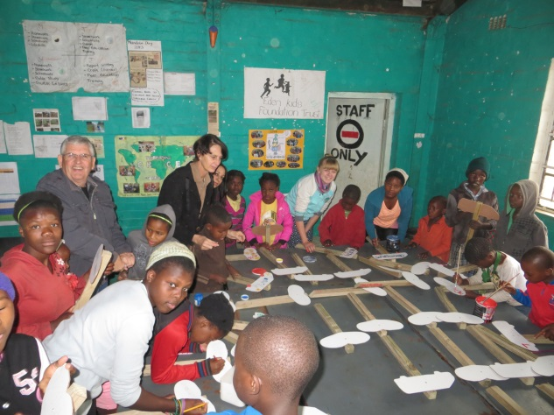

To find out more about Eden Kids Trust, contact Pastor Joel Ruttenberg
Cell 0745 850 860
E-mail ruttenbergj@gmail.com
Web page www.edenkids.weebly.com
Office 033 345 3245 – Fax 033 394 1173
164 Peter Kerchoff St
Pietermaritzburg
3201

